**DAILY ONLINE ACTIVITIES SUMMARY**

|  |  |  |  |  |  |  |  |  |
| --- | --- | --- | --- | --- | --- | --- | --- | --- |
| **Date:** | **28/06/2020** | | | | | **Name:** | **NIKHIL KUMAR** | |
| **Sem & Sec** | **4thSEM. & ‘B’ SEC.** | | | | | **USN:** | **4AL19CS400** | |
| **Online Test Summary** | | | | | | | | |
| **Subject** | | **NULL** | | | | | | |
| **Max. Marks** | | **30** | | **Score** | | |  | |
| **Certification Course Summary** | | | | | | | | |
| **Course** | **SQL and Relational Databases 101** | | | | | | | |
| **Certificate Provider** | | | **Cognitive class** | | **Duration** | | | **5hr** |
| **Coding Challenges** | | | | | | | | |
| **Problem Statement1 :** | | | | | | | | |
| **Status: Executed** | | | | | | | | |
| **Uploaded the report in Github** | | | | | **Yes** | | | |
| **If yes Repository name** | | | | |  | | | |
| **Uploaded the report in slack** | | | | | **Yes** | | | |

**Online Test Summary :NULL**

**Certification Course Summary: Today I have gone through the module3 in this I have learn something about the String patterns, Ranges and Sets.**

**Snapshot is given below**

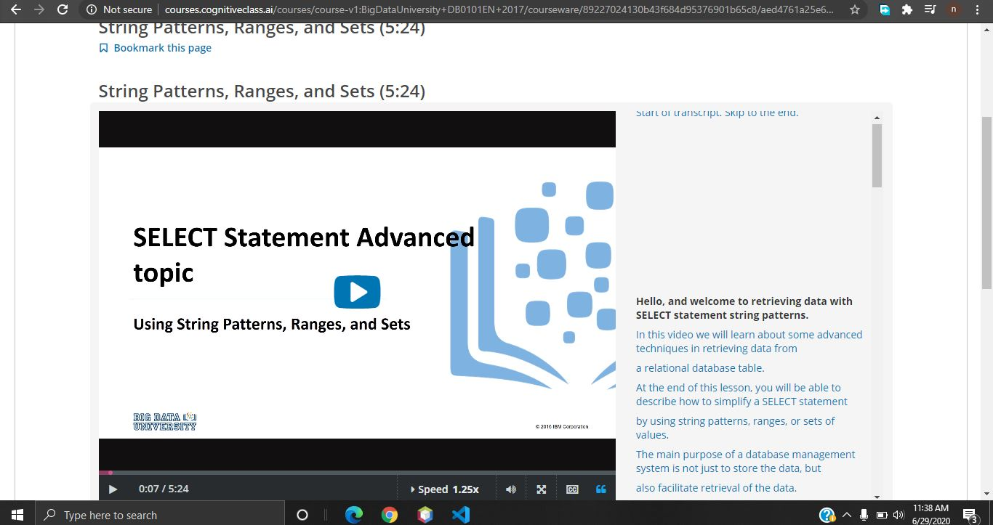

**Thank you.**